ME352A LAB-2

Group - A5

Members:

1.Asim Katakwar 150159

2.Atul Bimbrahw 150162

3.Avinash Kumar 150169

4.Ayush Singh 150177

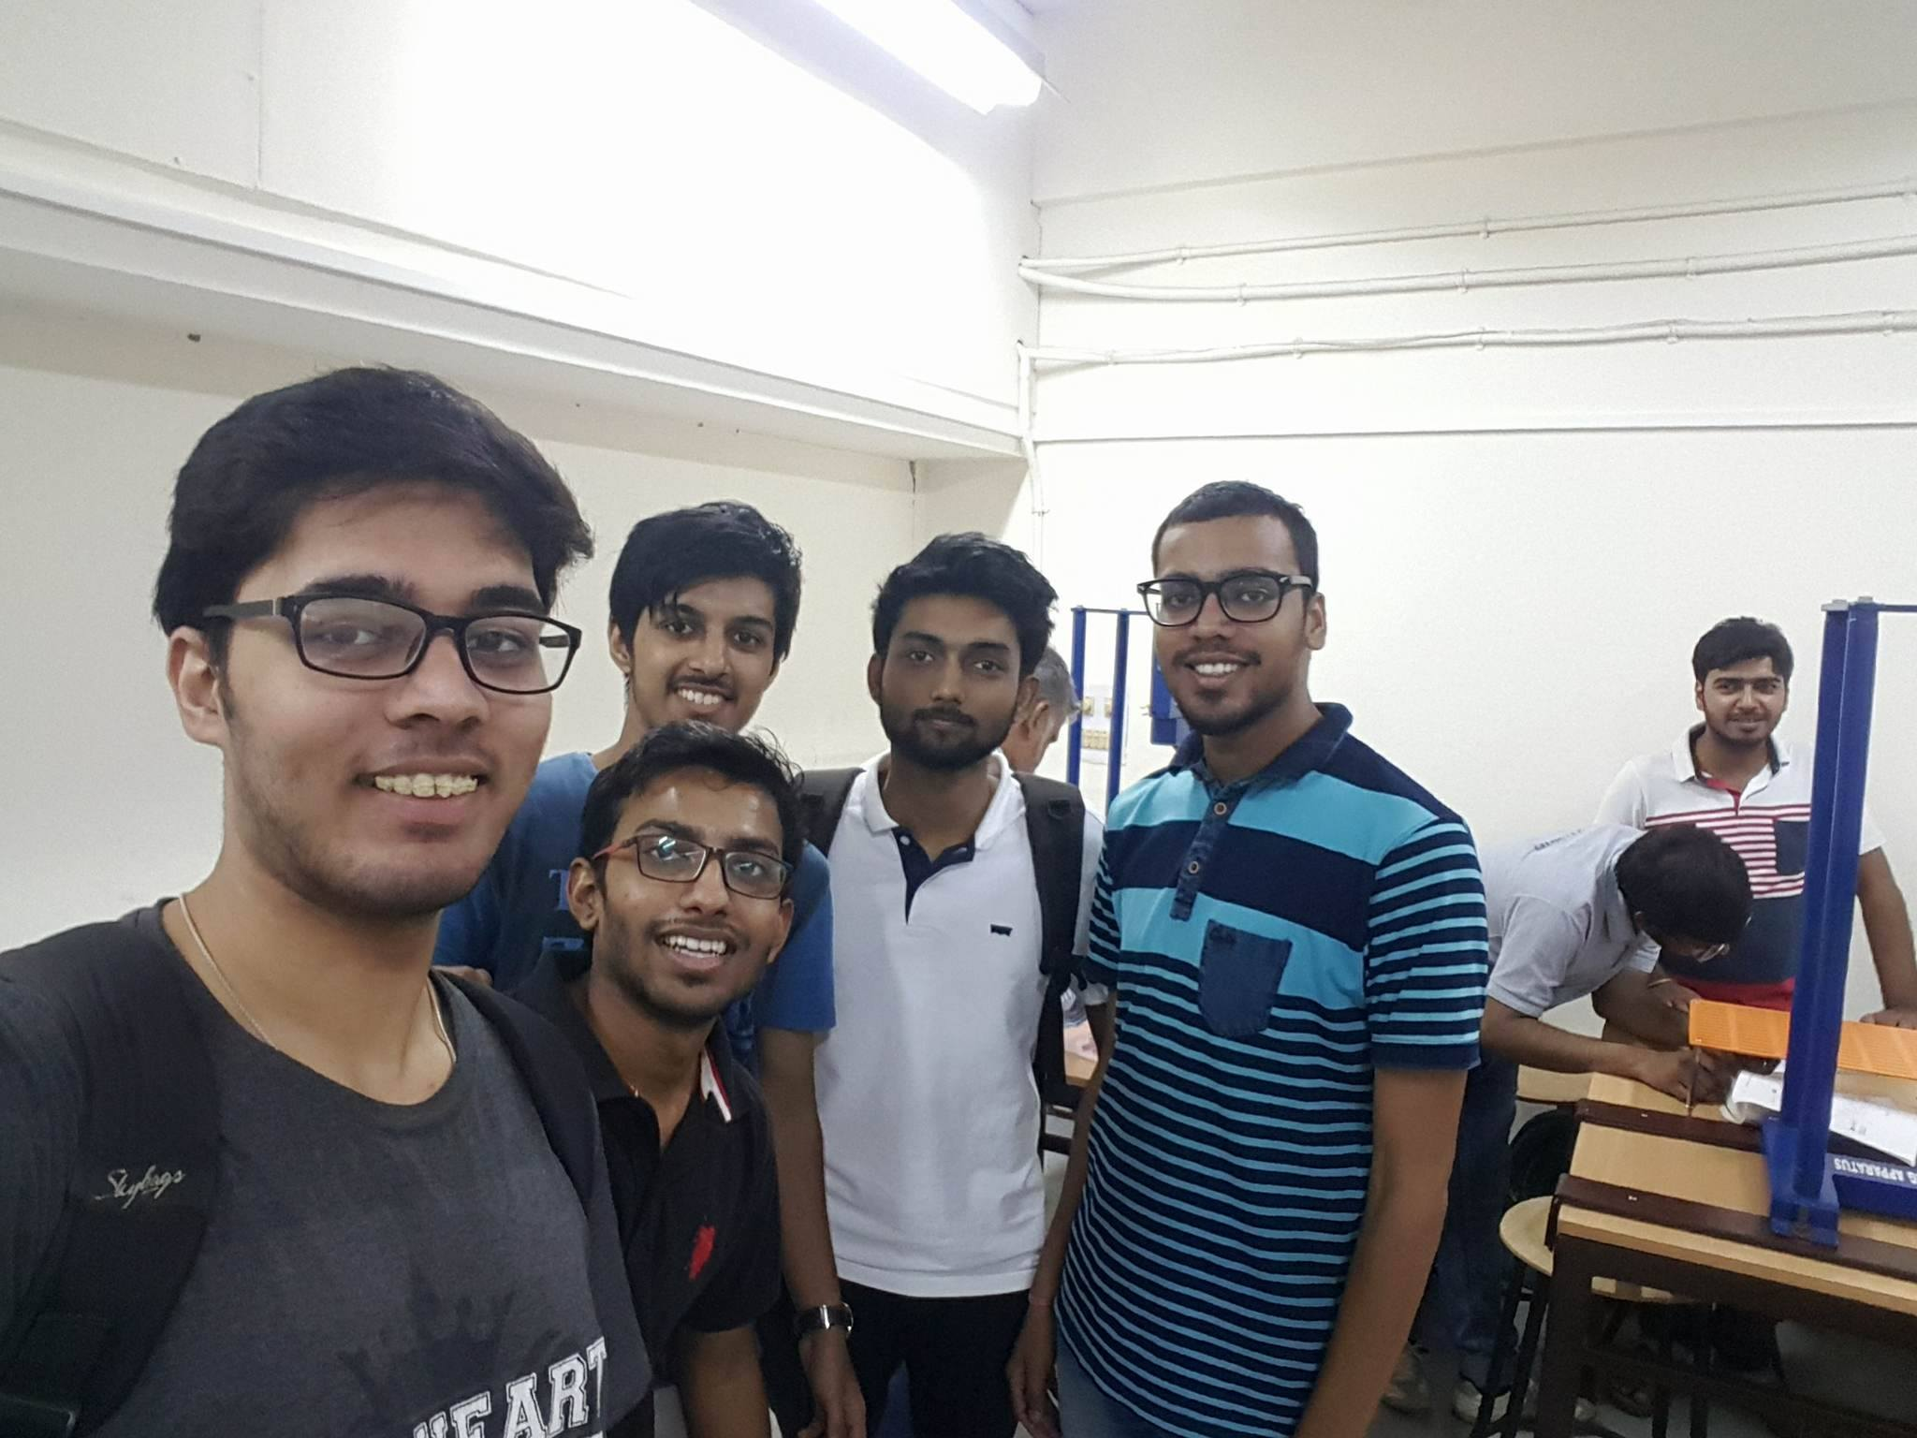

Mechanism 2B:

1.Satisfying Grashof Criterion

**Case A:**

Crank-Rocker Mechanism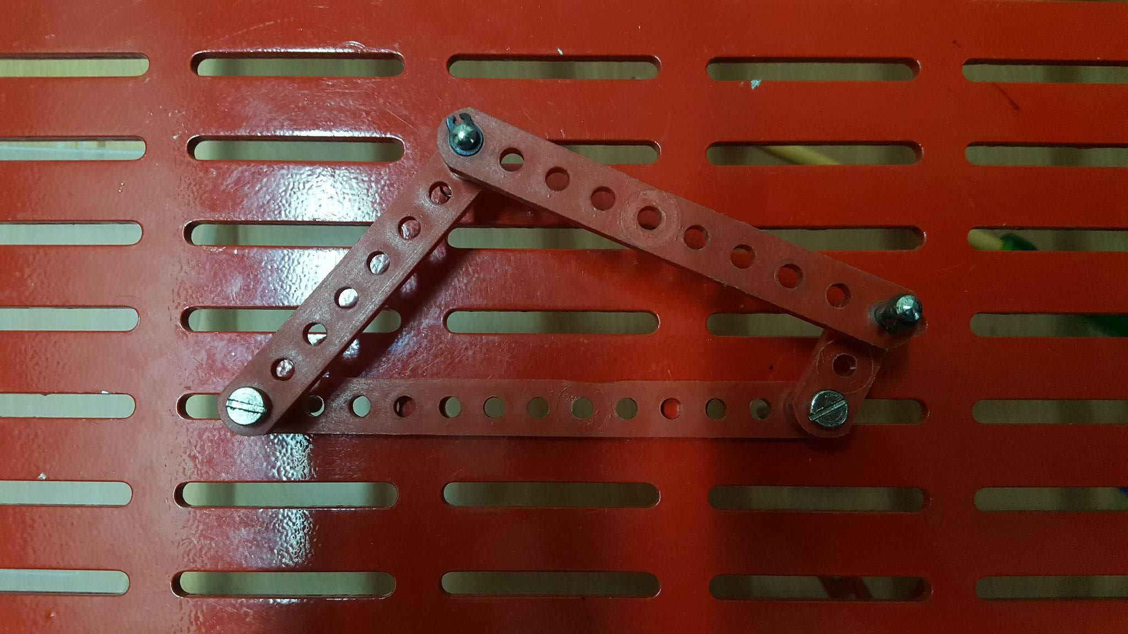Shortest length(Crank)=2cm

Longest length(Frame)=12cm

Rocker=7cm l'=9cm

**Case B:**

Double-Rocker Mechanism

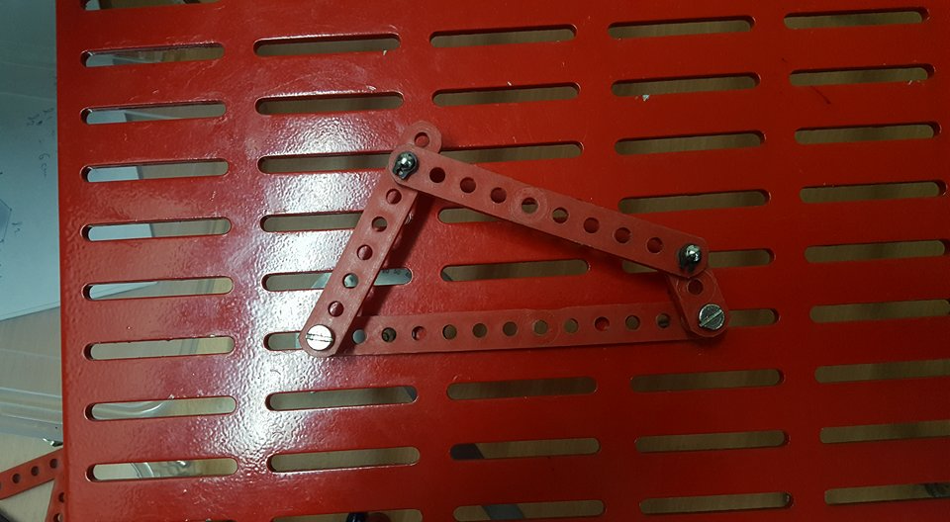

Longest length(Frame)=12cm

Shortest length=2cm

l1=6cm l2=9cm

**Case C:**

Double-Crank Mechanism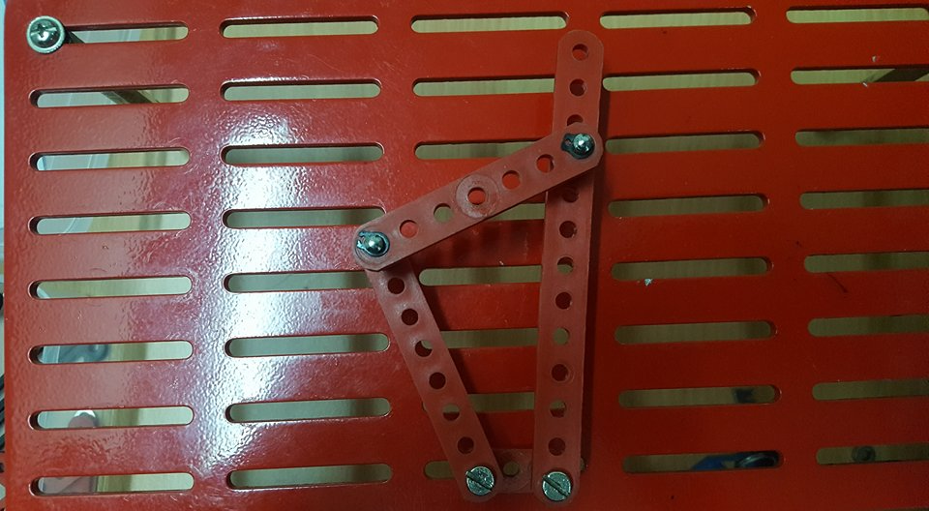 Shortest Length(Frame)=2cm

Longest length=12cm

l1(Crank)=6cm l2(Crank)=9cm

2.Non-Grashof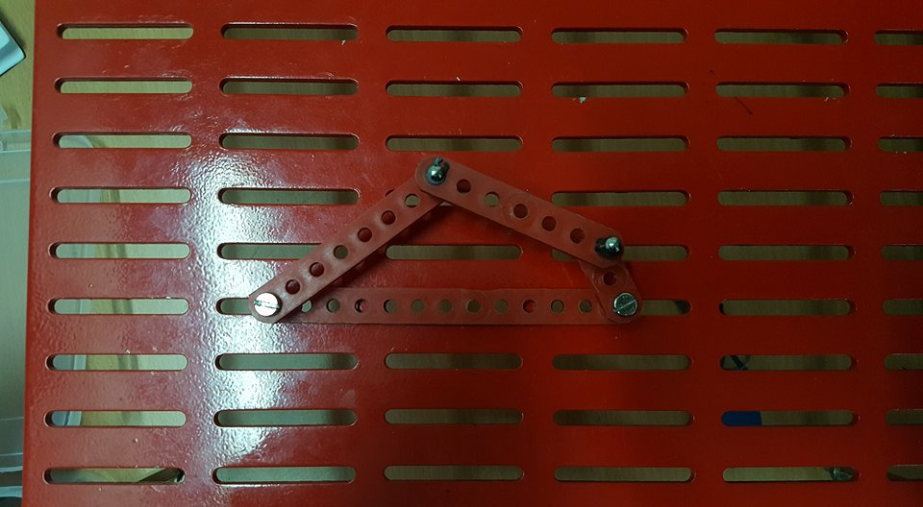

Shortest length=2cm

longest length(Frame)=12cm

l1=7cm l2=6cm

* Under Gashof Criterion in crank-rocker mechanism with lengths taken above we saw that the rocker angle increases with respect to crank angle up to 65 degrees when crank angle was 140 degrees and then starts to decrease(i.e. rocking) while in Non Grashof condition the rocker stops when crank angle is 296 degrees .
* If the Grashof condition is met, the Parts other than the shortest can only oscillate with respect to the others. If two parts can make a complete rotation, the two parts must be the shortest at the same time, and therefore have equal length.

MECHANISM 2C:

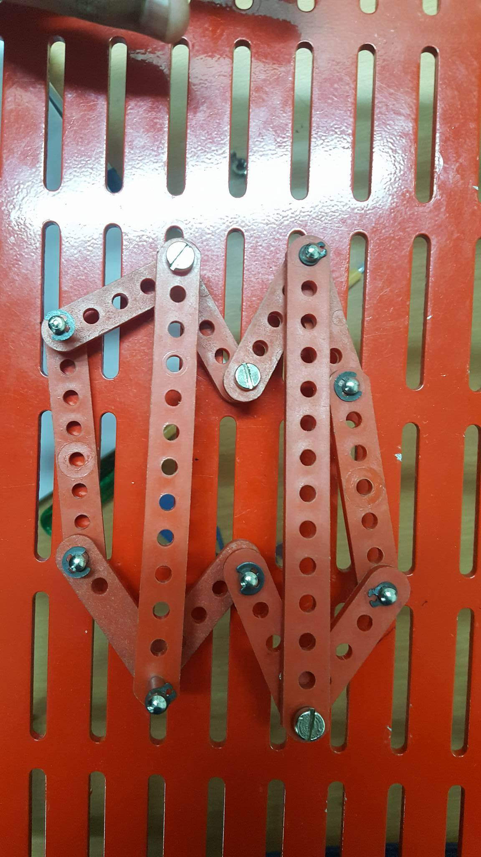

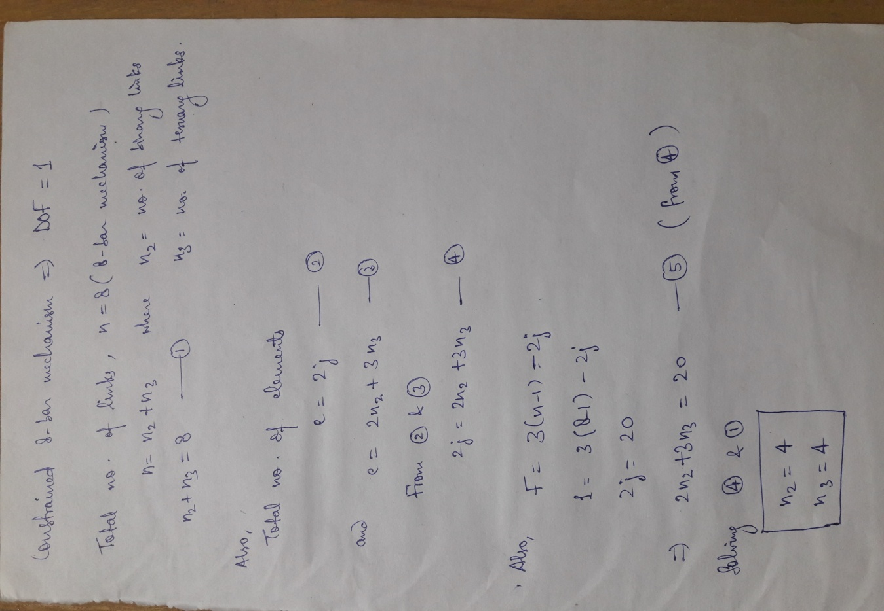

* some more 8 bar mechanism are Peaucellier-Lipkin linkage and Jansen's linkage.